Experiment No. 6
Threat Modeling and Security Hardening for an IoE Application
IoE Smart Banking System
Software-Based Simulation using Python and Google Colab

Name | ____________________________________________
Register No. | ____________________________________________
Department | Electronics and Communication Engineering
Date | ____________________________________________
Faculty Signature | ____________________________________________

1. Aim
To develop and simulate a software-based threat modeling and security hardening system for an IoE Smart Banking application using Python in Google Colab, with emphasis on authentication, ATM transaction monitoring, threat detection, transaction blocking, and security visualization.

2. Objectives
• To simulate secure user authentication for a smart banking environment.
• To generate and monitor ATM transactions from multiple IoE-enabled ATM nodes.
• To model common security threats such as ATM spoofing, brute-force attempts, data tampering, and DoS attacks.
• To classify transactions as SAFE or BLOCKED based on the simulated threat condition.
• To generate security statistics and graphs for analyzing transaction and threat behavior.
• To understand how software-level security hardening can reduce the impact of suspicious transactions in an IoE application.

3. Software Required
Software / Library | Purpose | Environment
Google Colab | Cloud-based Python execution | Web browser
Python 3 | Simulation and security logic | Google Colab
Pandas | Transaction data handling | Python library
Matplotlib | Graphs and visualization | Python library
hashlib | SHA-256 password hashing | Python standard library
random | Simulation of transactions and threats | Python standard library

4. System Overview
The proposed IoE Smart Banking Security System represents a software simulation of a banking environment containing multiple ATM nodes. Each ATM generates a customer transaction and an amount. A threat model randomly assigns a security condition to every transaction. SAFE transactions are marked SUCCESS, while transactions associated with a simulated threat are marked BLOCKED. The results are stored in a Pandas DataFrame and visualized using Matplotlib.

5. System Architecture
Layer | Component | Function
User Layer | Admin Login | Authenticates the banking administrator
IoE Layer | ATM001–ATM005 | Represents connected smart ATM nodes
Threat Modeling Layer | Threat Selector | Models safe and malicious conditions
Security Layer | Transaction Blocking | Blocks transactions classified as threats

6. Threat Modeling
Threat modeling identifies possible security risks affecting the IoE banking application and defines a basic response. In this simulation, five conditions are considered.
Threat / Condition | Possible Risk | Simulation Detection | Security Response
SAFE | No simulated attack | Threat = SAFE | Allow transaction
ATM Spoofing | Fake or unauthorized ATM activity | Threat label generated | Block transaction
Brute Force | Repeated unauthorized login attempts | Threat label generated | Block transaction
Data Tampering | Unauthorized modification of transaction data | Threat label generated | Block transaction
DoS Attack | Availability disruption | Threat label generated | Block transaction

7. Security Hardening Measures
Measure | Implementation in Simulation
Password hashing | The password is converted to a SHA-256 hash before the hash is displayed/stored in the simulation.
Authentication | Only the predefined administrator credentials are accepted by the simulated login stage.
Threat classification | Each transaction is classified into SAFE or one of four simulated threat categories.
Transaction blocking | Any transaction associated with a threat is marked BLOCKED rather than SUCCESS.
Security monitoring | A transaction report and threat statistics are generated for analysis.
Visualization | Graphs provide a quick view of transaction amounts, status, and threat distribution.

8. Procedure
1. Start the Python simulation.
2. Define the administrator username and password.
3. Generate the SHA-256 hash of the password.
4. Create a list of five ATM identifiers.
5. For every ATM, generate a customer ID and transaction amount.
6. Randomly select SAFE, ATM Spoofing, Brute Force, Data Tampering, or DoS Attack.
7. Assign SUCCESS to SAFE transactions and BLOCKED to all other transactions.
8. Store all records in a Pandas DataFrame.
9. Count each threat category and transaction status.
10. Plot four graphs using Matplotlib.
11. Display the security report and completion message.
12. Stop.

9. Python Program
# ======================================================
# Threat Modeling & Security Hardening
# IoE Smart Banking System
# Google Colab
# ======================================================

import random
import hashlib
import pandas as pd
import matplotlib.pyplot as plt

print("="*60)
print(" IoE SMART BANKING SECURITY SYSTEM ")
print("="*60)

# ----------------------------------------------------
# User Authentication
# ----------------------------------------------------

username = "admin"
password = "Bank@123"

password_hash = hashlib.sha256(password.encode()).hexdigest()

print("\nLogin Successful")
print("Username :", username)
print("Password Hash :", password_hash[:20],"...")

# ----------------------------------------------------
# Smart ATM Transactions
# ----------------------------------------------------

atm_ids = ["ATM001","ATM002","ATM003","ATM004","ATM005"]

records = []

for atm in atm_ids:

customer = random.randint(1001,1050)
amount = random.randint(500,10000)

threat = random.choice([
"SAFE",
"ATM Spoofing",
"Brute Force",
"Data Tampering",
"DoS Attack"
])

if threat=="SAFE":
status="SUCCESS"
else:
status="BLOCKED"

records.append([
atm,
customer,
amount,
threat,
status
])

# ----------------------------------------------------
# Display Transactions
# ----------------------------------------------------

df = pd.DataFrame(records,columns=[
"ATM ID",
"Customer ID",
"Amount",
"Threat",
"Status"
])

print("\nATM Transaction Report\n")
print(df)

# ----------------------------------------------------
# Security Summary
# ----------------------------------------------------

safe = len(df[df["Threat"]=="SAFE"])
spoof = len(df[df["Threat"]=="ATM Spoofing"])
brute = len(df[df["Threat"]=="Brute Force"])
tamper = len(df[df["Threat"]=="Data Tampering"])
dos = len(df[df["Threat"]=="DoS Attack"])

print("\n========== SECURITY REPORT ==========")
print("Safe Transactions :",safe)
print("ATM Spoofing :",spoof)
print("Brute Force :",brute)
print("Data Tampering :",tamper)
print("DoS Attack :",dos)

# ----------------------------------------------------
# GRAPH 1
# Transaction Amount
# ----------------------------------------------------

plt.figure(figsize=(8,4))
plt.bar(df["ATM ID"],df["Amount"])
plt.title("ATM Transaction Amount")
plt.xlabel("ATM")
plt.ylabel("Amount")
plt.grid(axis="y")
plt.show()

# ----------------------------------------------------
# GRAPH 2
# Success vs Blocked
# ----------------------------------------------------

success = len(df[df["Status"]=="SUCCESS"])
blocked = len(df[df["Status"]=="BLOCKED"])

plt.figure(figsize=(5,4))
plt.bar(["SUCCESS","BLOCKED"],[success,blocked])
plt.title("Transaction Status")
plt.ylabel("Count")
plt.show()

# ----------------------------------------------------
# GRAPH 3
# Threat Distribution
# ----------------------------------------------------

plt.figure(figsize=(6,6))
plt.pie(
[safe,spoof,brute,tamper,dos],
labels=[
"SAFE",
"ATM Spoofing",
"Brute Force",
"Tampering",
"DoS"
],
autopct="%1.1f%%",
startangle=90
)
plt.title("Threat Distribution")
plt.show()

# ----------------------------------------------------
# GRAPH 4
# Customer Transaction Amount
# ----------------------------------------------------

plt.figure(figsize=(8,4))
plt.plot(df["Customer ID"],df["Amount"],marker="o")
plt.title("Customer Transaction Amount")
plt.xlabel("Customer ID")
plt.ylabel("Amount")
plt.grid(True)
plt.show()

print("\n======================================")
print("Threat Modeling Completed Successfully")
print("Security Hardening Applied")
print("System Protected Successfully")
print("======================================")

10. Simulation Output
The following table shows one reproducible run of the software simulation. The original program uses random values, so the transaction values and threat labels may change each time the code is executed.
ATM ID | Customer ID | Amount | Threat | Status
ATM001 | 1041 | 2324 | SAFE | SUCCESS
ATM002 | 1048 | 5006 | ATM Spoofing | BLOCKED
ATM003 | 1015 | 2786 | SAFE | SUCCESS
ATM004 | 1044 | 9435 | SAFE | SUCCESS
ATM005 | 1038 | 7412 | SAFE | SUCCESS
Security Summary: Safe Transactions = 4, ATM Spoofing = 1, Brute Force = 0, Data Tampering = 0, DoS Attack = 0.
Transaction Status: SUCCESS = 4, BLOCKED = 1.

11. Graphical Results
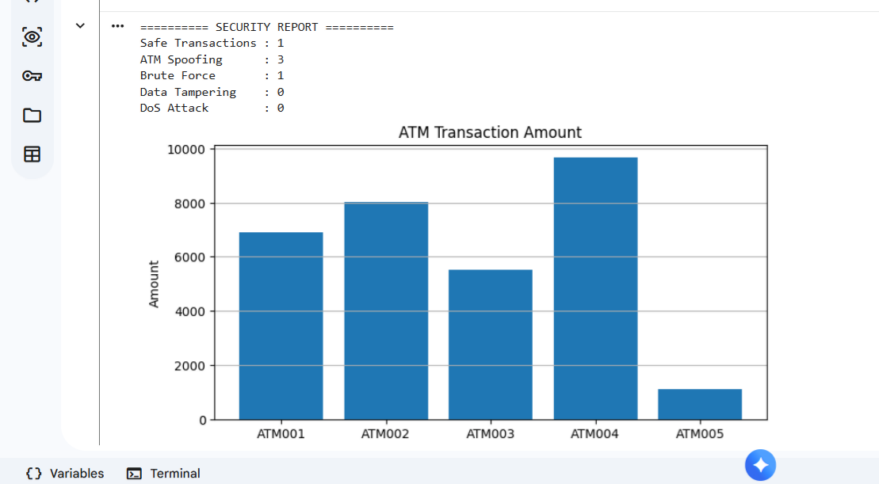
Figure 1: ATM transaction amount
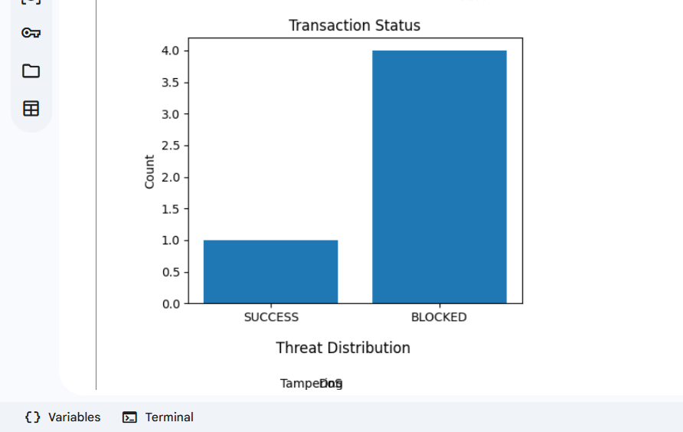
Figure 2: SUCCESS versus BLOCKED transactions
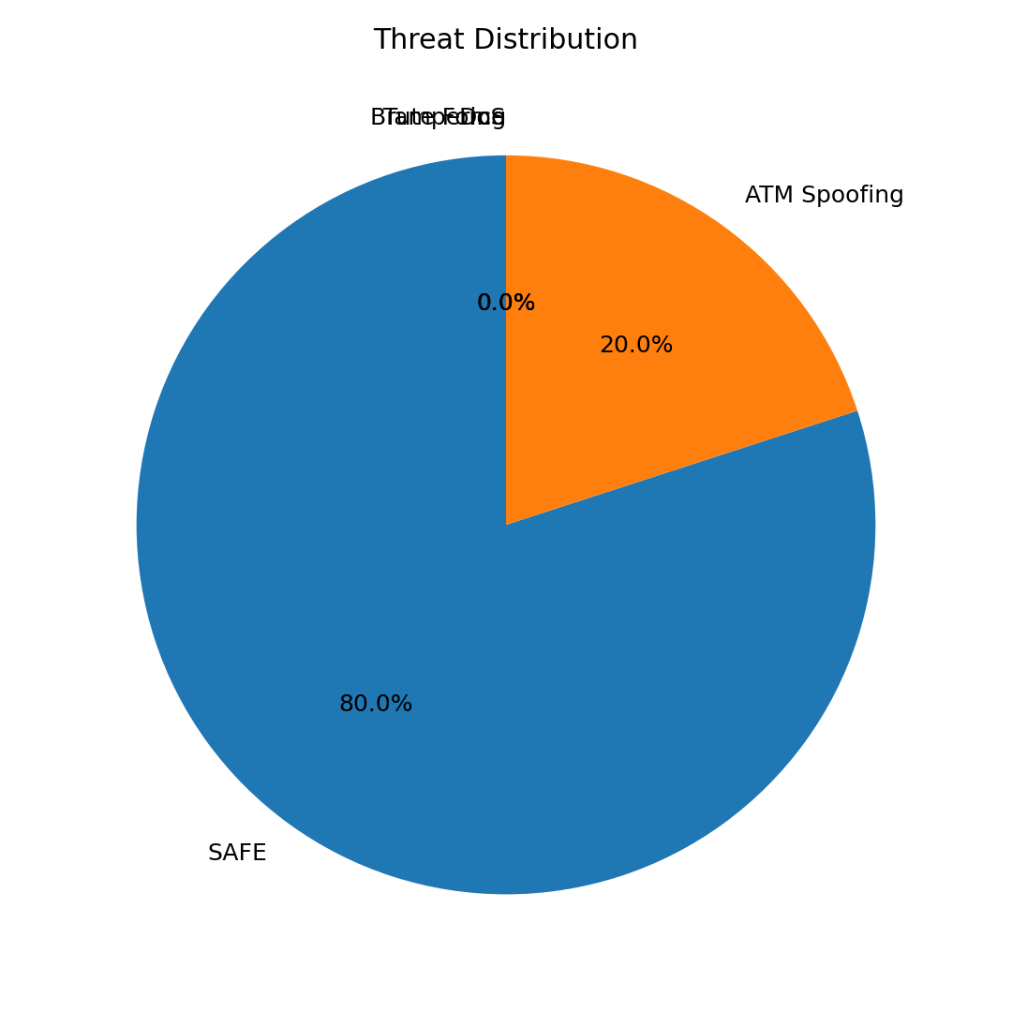
Figure 3: Threat distribution
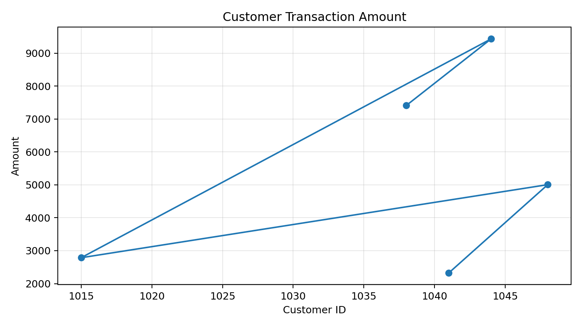
Figure 4: Customer transaction amount

12. Result
The IoE Smart Banking Security System was successfully simulated using Python in Google Colab. The program generated ATM transactions, modeled common security threats, classified transactions as SUCCESS or BLOCKED, and produced security statistics and graphical visualizations. The simulation demonstrates how basic threat modeling and security hardening can be incorporated into an IoE banking application without requiring physical hardware.

